Wellington Farms Homeowners Association (WFHA)

ANNUAL MAINTENANCE FEE INVOICE AND NEW WEBSITE REGISTRATION REQUIREMENT
To: Fellow Wellington Farms Homeowner
From: Wellington Farms Homeowners Association (WFHA) Board of Officers and Directors
Subject: Annual Maintenance Fee for the period October 1st, 2017 through September 30th, 2018
One of the primary goals of the WFHA Board is to conduct HOA business in the most cost effective, efficient way possible. Toward that end, we have once again streamlined our payment process. As you know, over the past few years, we offered an electronic means to pay our fees through PayPal. While somewhat effective, it was still cumbersome to process for various reasons. In order to keep our costs at a minimum, we are requiring all homeowners to register on our new website to help facilitate an even more efficient payment process for our fees. The following instructions will help you register:
- Access the webpage at https://wfha.hoa-express.com/.
- In the upper right-hand corner, click on the “register” option.
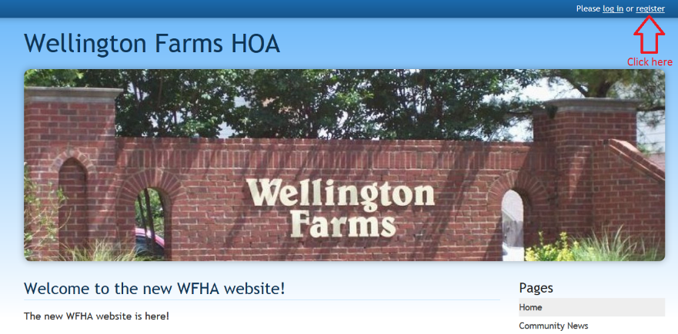
- Fill in all the required information. You will need a valid email address to do so.
- Click the “Register” button at the bottom of the page and you’re done.
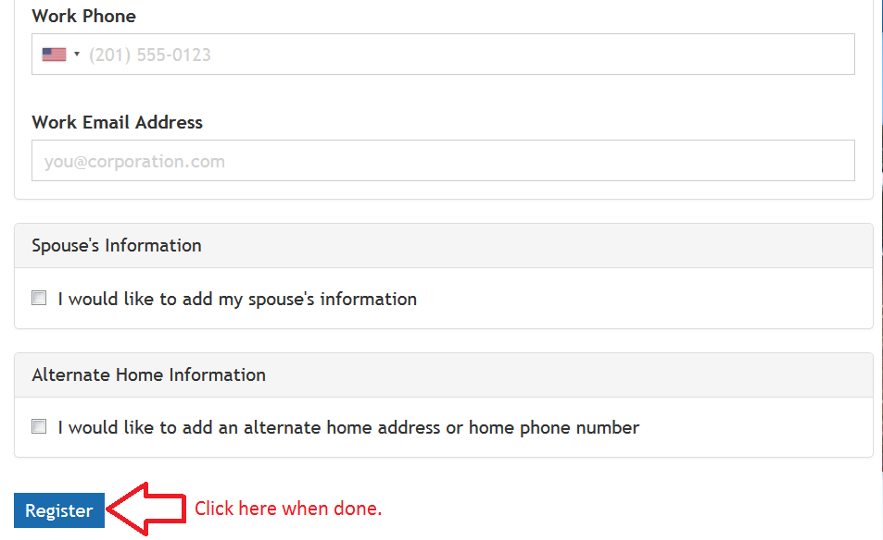

Once you register, one of the WFHA board members will review and approve your registration. This will allow you to pay your fees from the website. Once your registration is approved, you can log back into the website and click on the “bell” icon in the upper right-hand corner of the home page. This is a link to the online payment page.
The website offers two methods of payment, either credit card or bank draft directly from your checking or savings account, whichever you prefer. The annual maintenance fees still remain at $175. They are due by October 31st, 2017. If not paid by then, there is a 10% ($17) late assessment bringing the amount owed to $192.
If, for some reason, you do not wish to pay your fees from the website, you can do so by processing a transfer from your local bank branch to our HOA checking account. The HOA checking account information is as follows - Bank Routing #064003962 and Checking Account #8021296051. Please ensure your name and address are included with the transfer documentation.
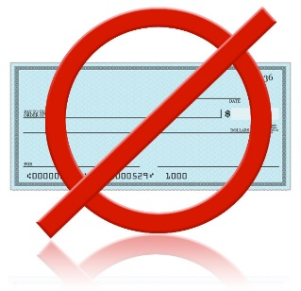
Unfortunately, we can no longer accept handwritten checks. This process has proved to be too cumbersome, has too much potential for error and is not environmentally friendly. The new process is quicker and allows each homeowner the flexibility of two payment methods from one location.
Keep in mind, regardless of your method of payment, it is now a requirement to register as a homeowner on the new website. In fact, all new prospective homeowners are required to do so before they can close on their new homes.
If you need assistance registering or encounter any problems processing your payment, please contact the WFHA Treasurers, Tom Stoll (901-606-6794), Alberto Tormin (901-413-7344) or Bev Michalek (901-240-4040).

